CPSC 535 9/7/2022

1. Radix Sort
   1. 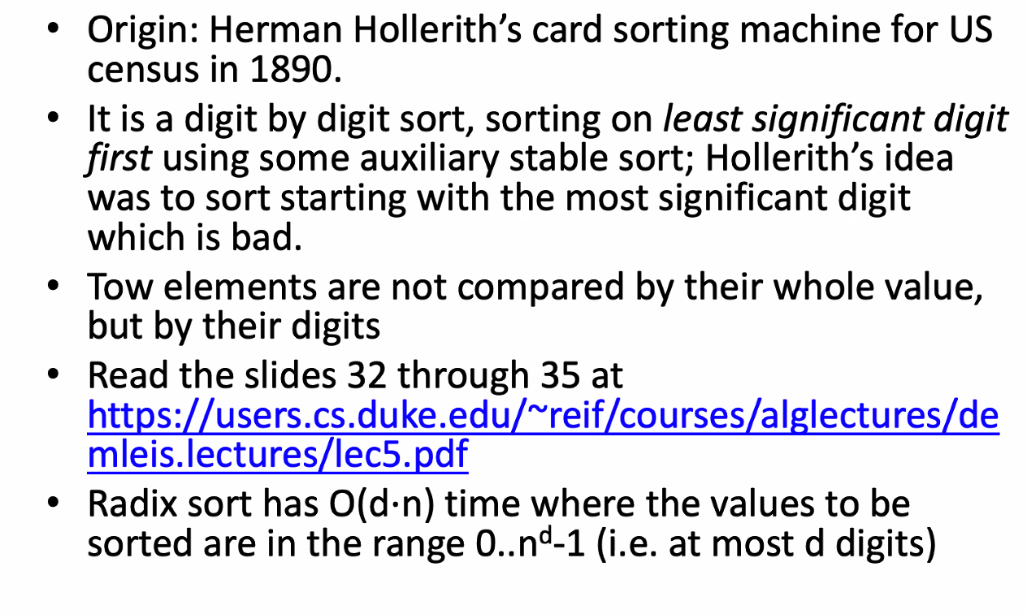
   2. Time Complexity = O(d*n)
      1. N = number of numbers
      2. D = number of digits
         1. Eventually, D = log(n)
      3. O(log(n)*n)
   3. 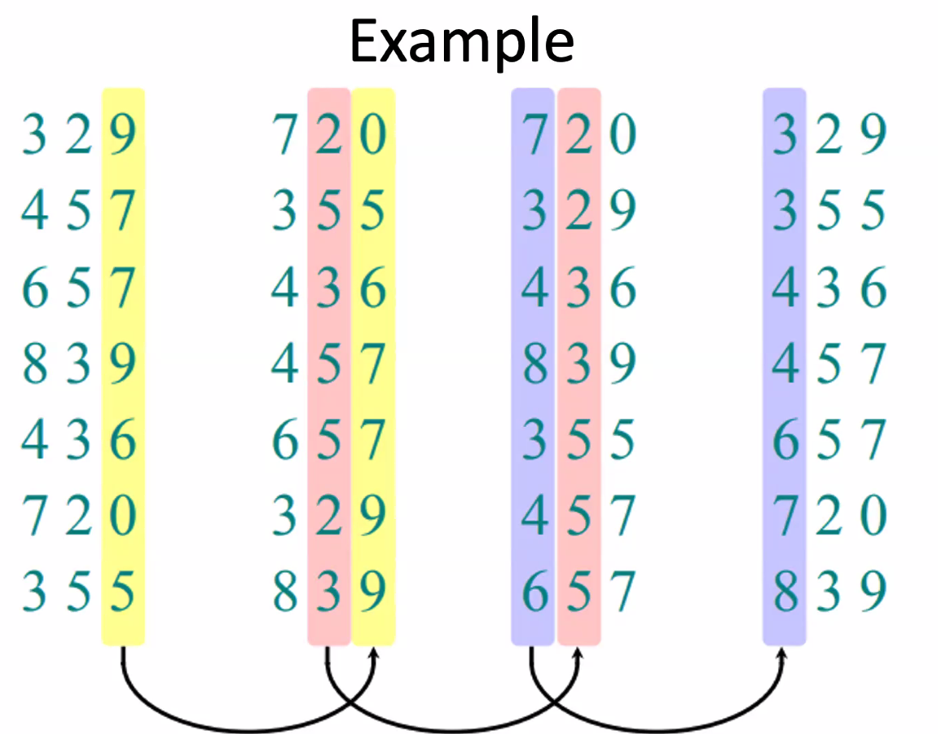
      1. It continues forever
      2. Compare 1st and 4th column
2. Bucket Sort
   1. 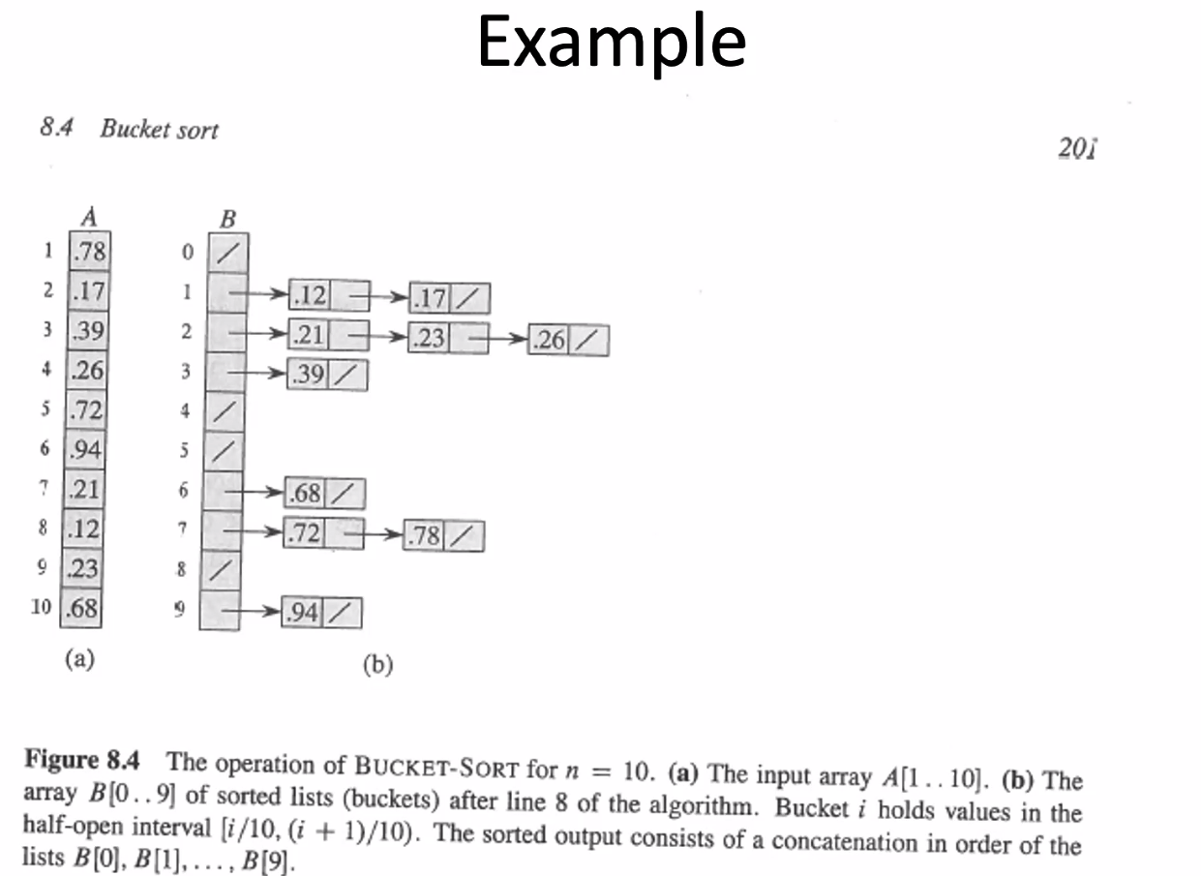
   2. 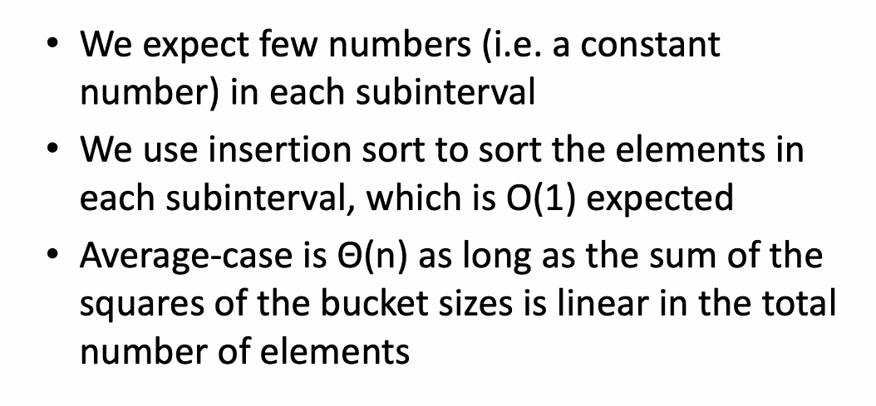
   3. This concludes the Linear Sorting Algos
3. Next Monday we have an in-class assignment T_T
   1. Computational problem
   2. Sorting Algorithm
   3. Open Textbook
4. Fundamental Data structures
   1. 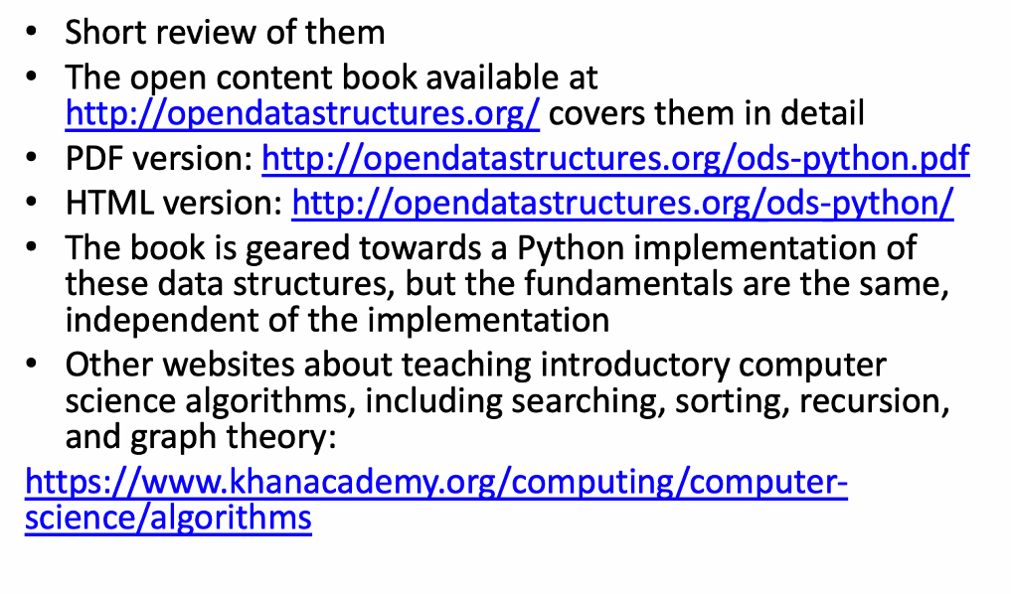
   2. Abstract Data Types (ADT)  
      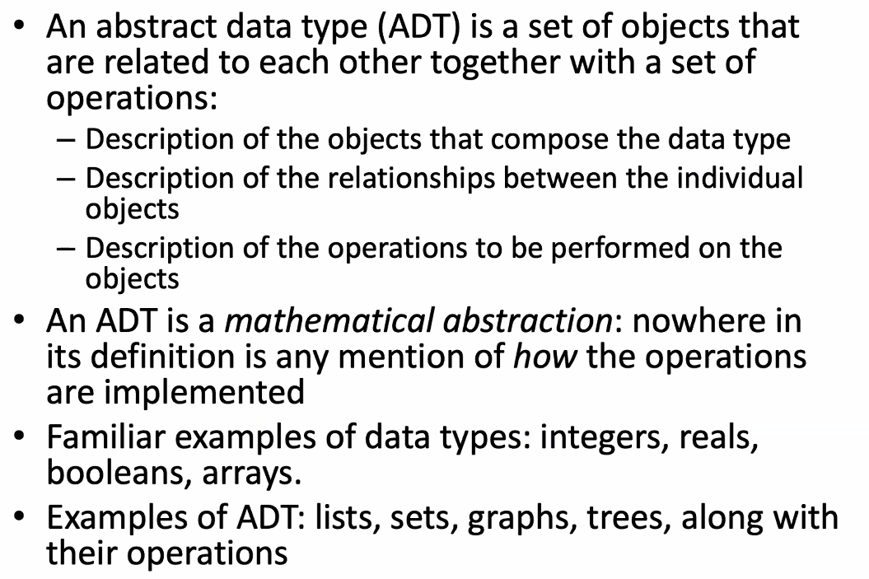
      1. What program does is handle data
   3. ADT vs. its Implementation  
      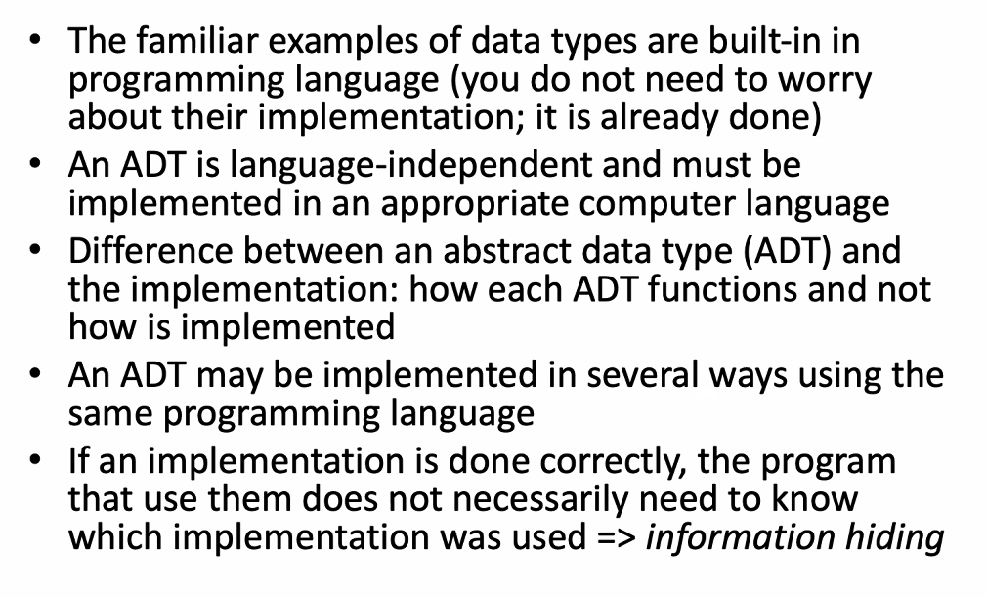
      1. We care about functions do and not how it’s implemented
5. Array ADT
   1. 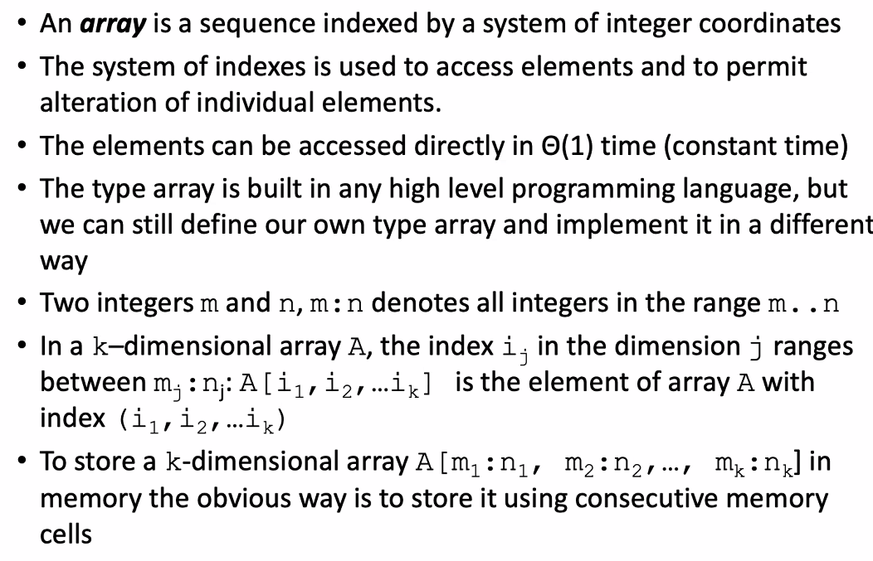
   2. A sequence indexed by integers
   3. Accessed O(1) = constant time
   4. 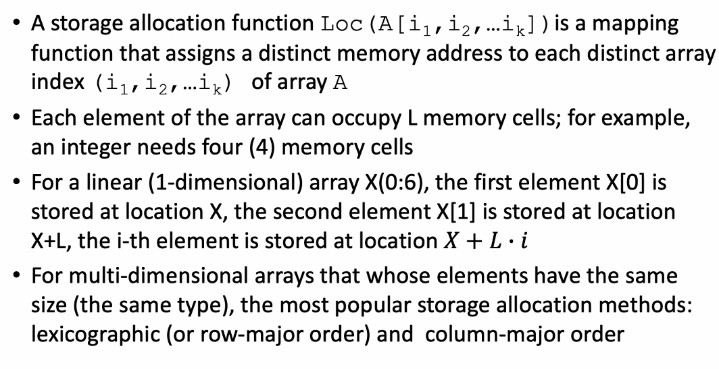
6. Lexicographic (Row-Major) storage allocation  
   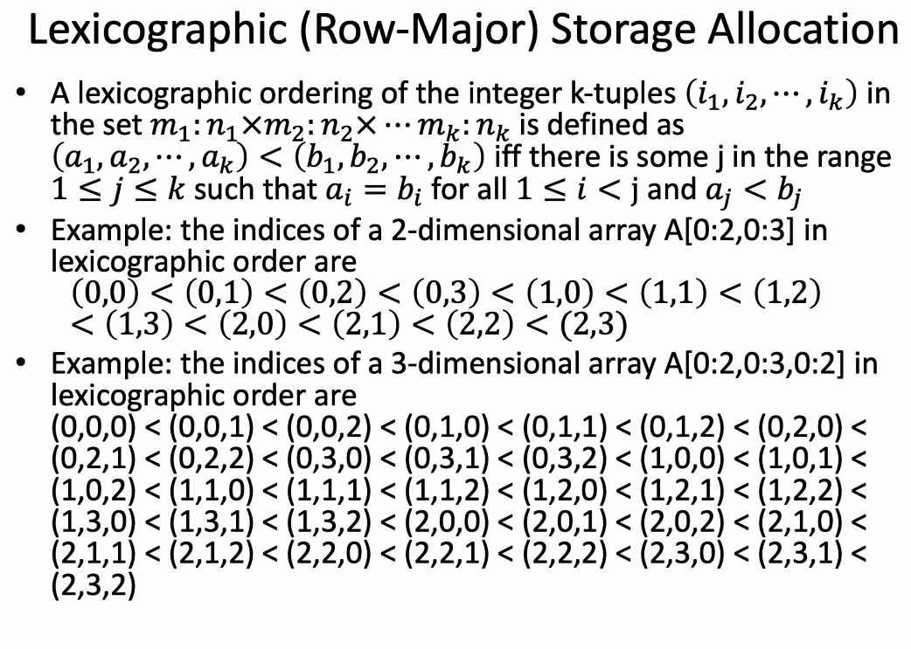
   1. 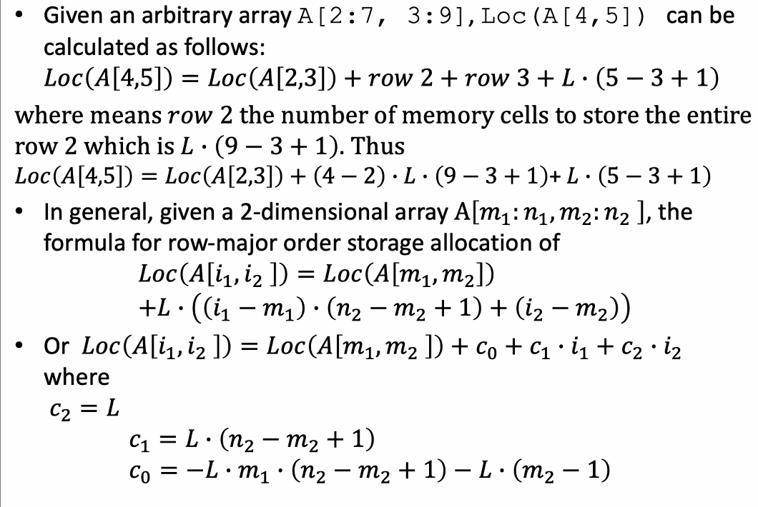
   2. 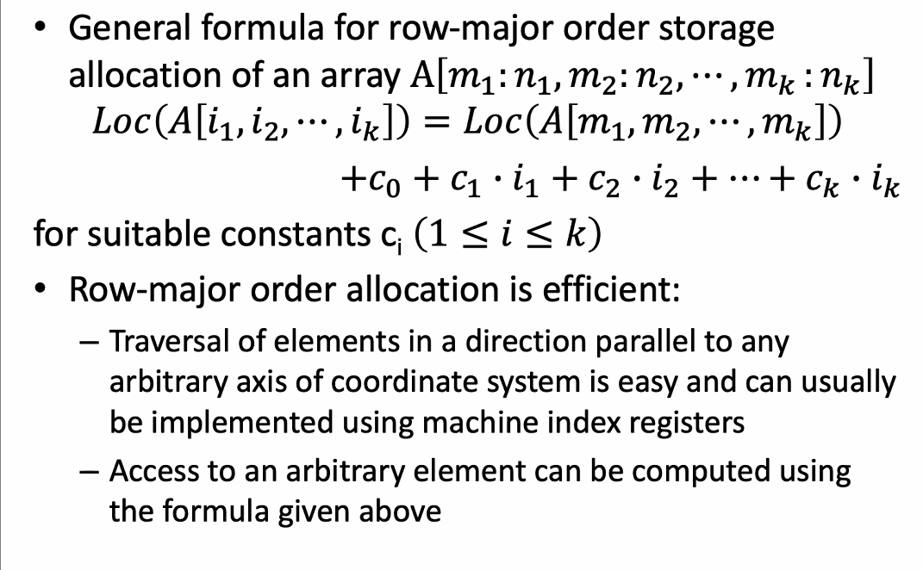
7. Column-major storage allocation
   1. 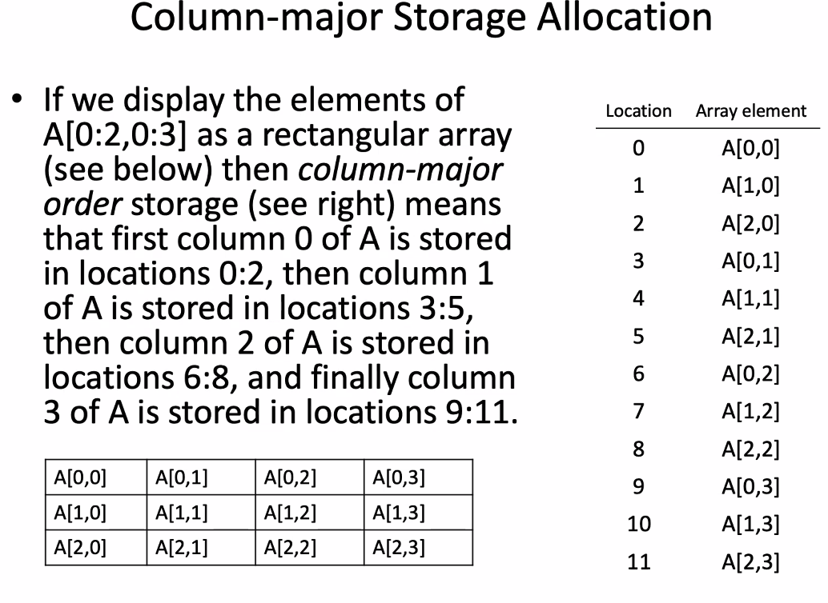
   2. 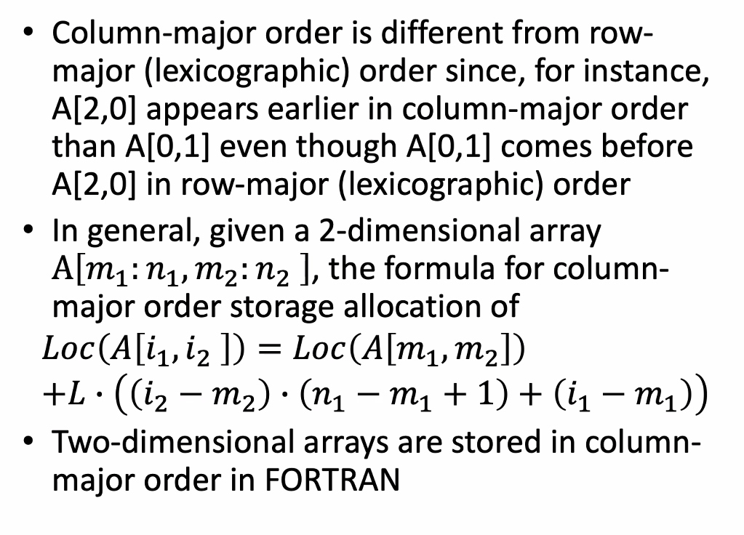
      1. FORTRAN is program of choice for supercomputers
8. Sparse Array ADT
   1. 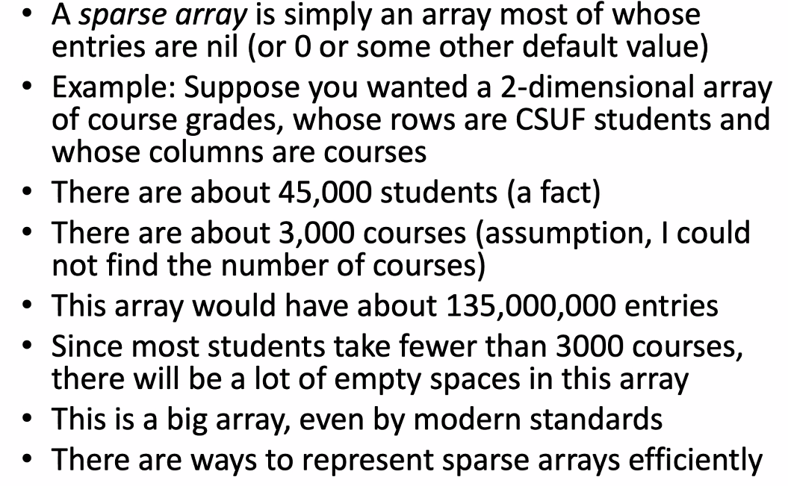
   2. 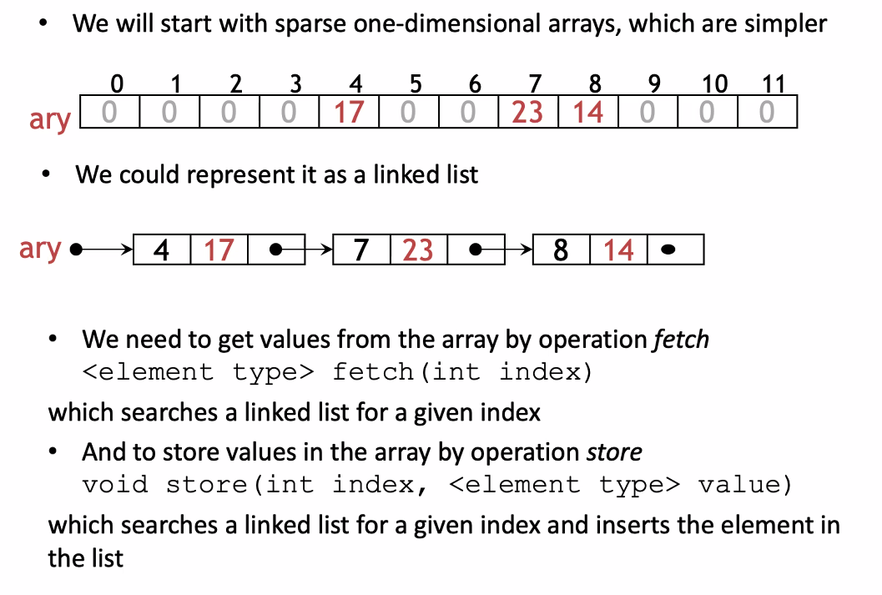
   3. 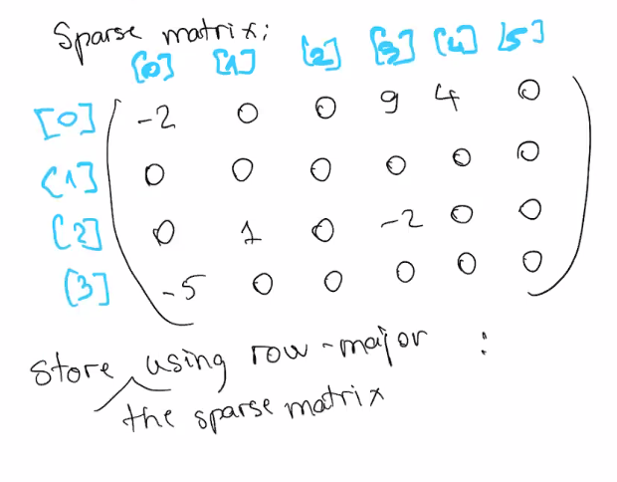
      1. Row Major
         1. 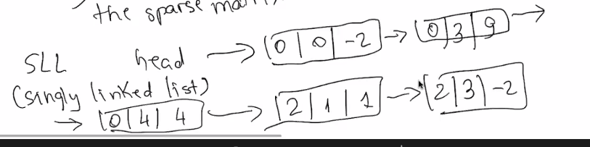
      2. Column-Major
         1. 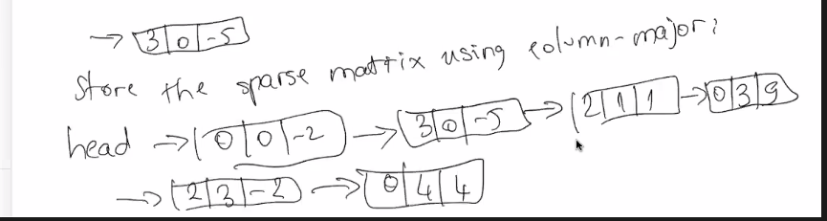
9. Dynamic Sets
   1. 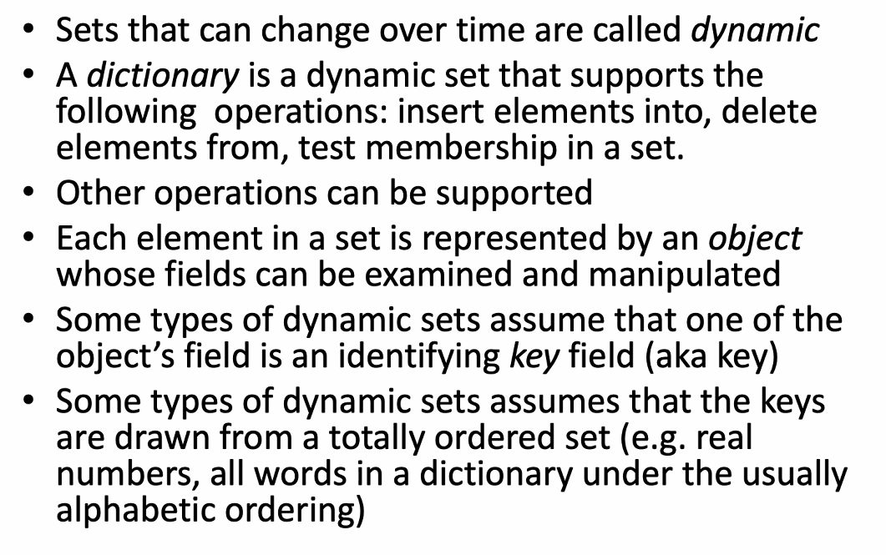
   2. Operations on dynamic sets  
      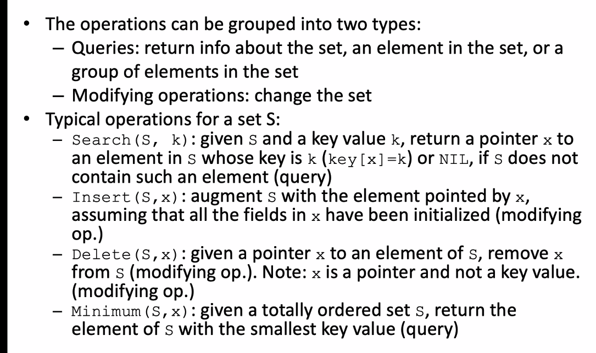
10. Priority Queue
    1. 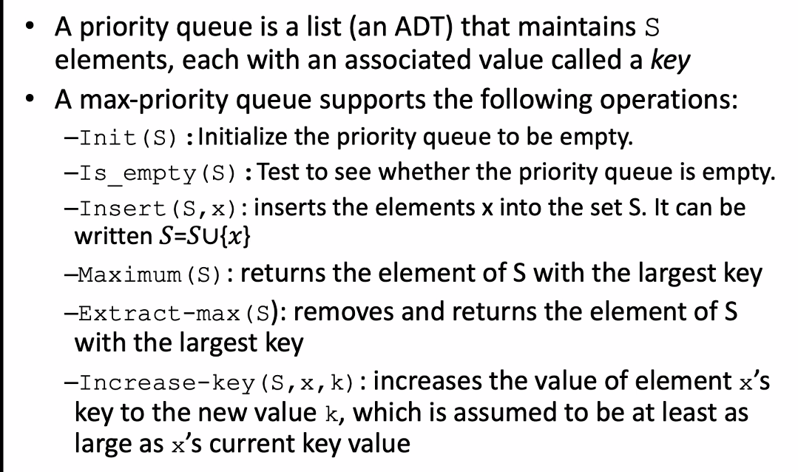
    2. Min-priority queue sample  
       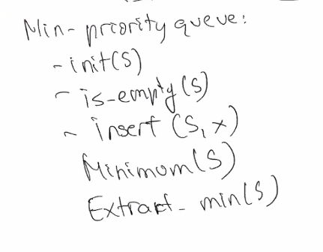
       1. 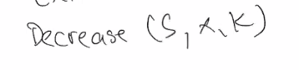
          1. if element has priority, then one would be
          2. for more info, look up HEAP SORT in book